Practice headed paper – This letter includes text boxes to be completed before sending

Dear Click here to enter text.
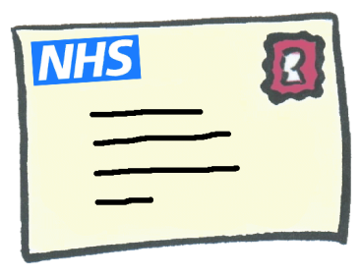 | We are inviting you for cervical screening.  This is sometimes called a smear test.
Easy read leaflets can be found at:

https://www.gov.uk/government/publications/cervical-screening-easy-read-guide

Or

http://www.jostrust.org.uk/resources/materials/information

A YouTube video is available at:

https://www.jostrust.org.uk/video-page/smear-test-film
 | The nurse at the surgery can tell you more about cervical screening.
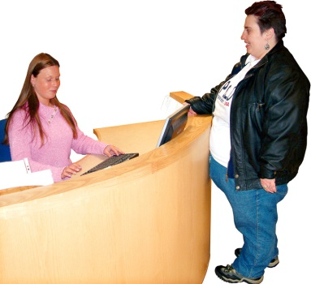 | To make an appointment phone Click here to enter text.  or come into the surgery.
 | You can bring a friend or carer with you.
 | If you are confused or worried and need more help to understand cervical screening the learning disability team can help.
 | The community learning disability team can be contacted on: 01642 283700

Yours sincerely

