Dear

  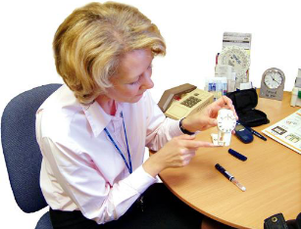    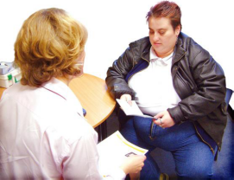     | We are writing to invite you to have cervical screening, this is sometimes called a smear test. This is an important part of looking after yourself  Every woman is asked to go for screening after the age of 25 and until they are 64 years old.  This is because cervical screening checks if you have changes to your cervix, which is inside your body at the top of your vagina, so you cannot see it.  Finding changes early can help protect you from cervical cancer.  If you are aged between 25 years and 49 years old we will invite you for a test every 3 years. When you are 50 years or older you will be invited to have a test every 5 years.  You are welcome to bring someone you trust with you, if you want to.  Don’t worry if you don’t like the idea of having a test, many women feel like that. We will try and make it as comfortable and easy as we can.  If you are not sure about having cervical screening tell us and we can discuss any questions or worries you have.  To make an appointment for your test please ring us on:  [TELEPHONE NUMBER]  [GP PRACTICE DETAILS]
Thank you and we look forward to seeing you.

Cervical Screening Lead


You can get more information online at:
www.jostrust.org.uk
www.cancerscreening.nhs.uk

