Accessing the CDRC Resources - SystmOne

How do I access the CDRC resources?

If I join the DCS group, will I share any of my organisation’s data out to anyone else?

Can I choose which DCS resources I’d like to be active / inactive?

How do I access the CDRC resources?
  - Firstly you’ll need to join the DCS Organisational Group from within S1 (you will need to have System Administrator access rights within your organisation/practice in order to do this):
    - 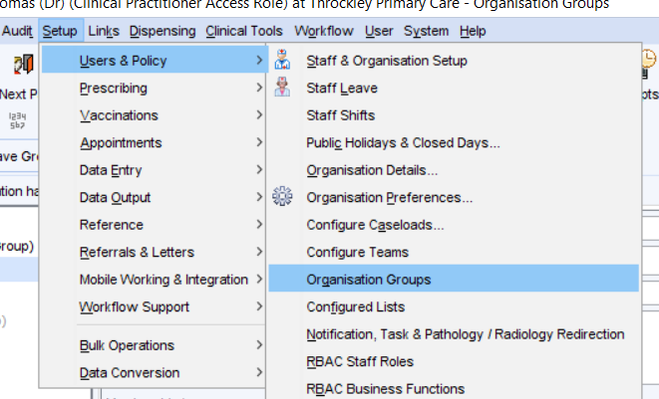
    - 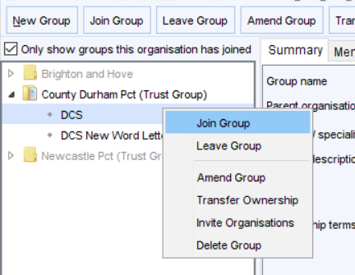
    - (Please also join the ‘DCS New Word Letter’ group too – this will just ensure that you have the most up-to-date letters)
    - Your request to join the group will need to be accepted; once this is done you will have access to all the resources.

If I join the DCS group, will I share any of my organisation’s data out to anyone else?
  - No. Joining the group does not permit any access to any of your organisation’s data (patient or otherwise) to other organisations.

Can I choose which DCS resources I’d like to be active / inactive?
  - Yes. All the elements of the DCS group are optional.
  - NB By default: Patient Status Alerts and a proportion of Protocols are set to be auto-activated when you join the DCS group. These can be turned off if required:
    - To turn off Patient Status Alerts (these are the small icons which appear under the patient demographics):
      - Navigate to the PSA management area and untick the ‘enabled’ box for the PSAs that you do not want to use:
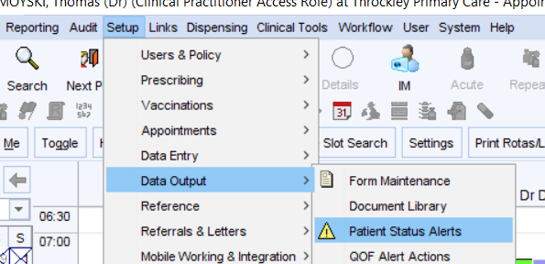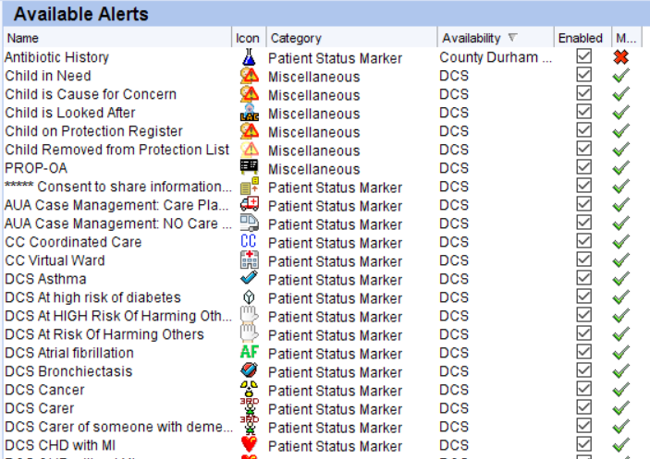

    - To turn off Protocols (these are the pop-up boxes/prompts which appear):
      - Navigate to the protocol management area and untick the ‘active’ box for any protocols that you don’t wish to use:
