Northern Cancer Alliance ‘Help Us Help You’
Week 2 communications toolkit
July, 2020

Please find below updated communications materials focusing on Week 2 of our Help Us Help You regional awareness campaign

Website/Intranet copy
Communities come together to create cancer awareness films

A series of films have been developed with black, Asian and minority ethnic communities and people with learning disabilities as part of a regional cancer campaign.

The Northern Cancer Alliance enlisted the support of people within the region to develop a suite of impactful films that are accessible to the diverse communities across the North East and North Cumbria.

The region has some of the highest rates for incidence of all cancers across England and some of the worst health inequalities. The ‘Help Us Help You’ campaign was launched to reassure people that cancer services remain a top priority for the NHS, and to encourage people not to delay contacting their GP or nurse if they are concerned about signs or symptoms of cancer.

By working closely with representatives from black, Asian and minority ethnic groups and people with learning disabilities to create the films, it is hoped that the important messaging will reach far and wide within regional communities.

One of the films - the ‘Time to Talk about Cancer’ – was created by and for people with learning disabilities. Developed by the Be Cancer Aware team, a co-production project led by the North East and Cumbria Learning Disability Network and supported by the Alliance, the four-minute film features people with a learning disability talking about the common signs of cancer, the importance of knowing what is normal for you and encouraging people with any concerns to tell their doctor.

Julie Tucker, Macmillan Project Manager, North East and Cumbria Learning Disability Network, said: “We need to ensure the messages we share are accessible to everyone. It is important people with a learning disability understand the signs of cancer and when to contact their GP so they too can receive early diagnosis and the best possible care and treatment.”

The Northern Cancer Alliance was also supported by members of the black, Asian and minority ethnic community across the region to record a series of awareness films to support communities speaking Punjabi, Arabic, Farsi, Pashto, Hindi-Urdu, and Mirpuri.

Shazia Noor, from NUR Fitness, is working with the Alliance to develop a community cancer awareness programme for the black, Asian and minority ethnic community and has been instrumental in the development of the campaign films.

She said: “It’s crucial that the message of cancer awareness is shared widely amongst the black, Asian and minority ethnic communities. Any message needs to be accessible in a variety of languages and culturally appropriate to have a positive and long-lasting impact. A strong cancer awareness campaign will enable members from the black, Asian and minority ethnic communities to develop an understanding of the signs of cancer, resulting in an increase in screening and earlier detection.”

Find out more about the ‘Help Us Help You’ regional campaign at: https://www.northerncanceralliance.nhs.uk/helpushelpyou

The black, Asian and minority ethnic resources can be accessed here: https://www.northerncanceralliance.nhs.uk/helpushelpyou/resources-information/patient-information-our-communities/black-asian-and-minority-ethnic/

The Be Cancer Aware films for people with learning disability can be found here: https://www.northerncanceralliance.nhs.uk/helpushelpyou/resources-information/patient-information-our-communities/be-cancer-aware/

ENDS

Social media content
Please follow us on Twitter and tag us in your tweets @NorthernCancer
Post copy | Asset
Check out this new film from the Be Cancer Aware team to support @NorthernCancer’s #HelpUsHelpYou campaign.  It was created by people with learning disabilities to help others with a learning disability to recognise the signs of #cancer @necldnetwork  https://youtu.be/IaL-RcyQ9Vs | YouTube link will create thumbnail
A series of films encouraging people to seek medical advice if they notice any cancer symptoms have been created to support communities speaking Punjabi, Arabic, Farsi, Pashto, Hindi-Urdu & Mirpuri as part of the #HelpUsHelpYou campaign from @NorthernCancer  https://www.northerncanceralliance.nhs.uk/helpushelpyou/resources-information/patient-information-our-communities/black-asian-and-minority-ethnic/ | NCA Shazia quote  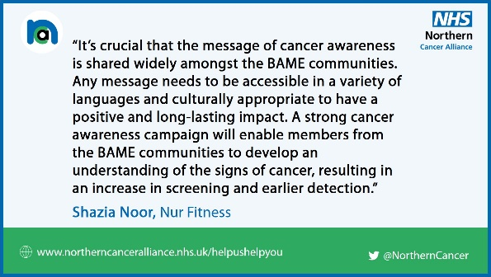
The @NorthernCancer Alliance has enlisted the support of people across the region to develop a suite of impactful #cancer awareness films to support the diverse communities across the North East and North Cumbria. Find out more about the resources here: https://www.northerncanceralliance.nhs.uk/helpushelpyou/resources-information/patient-information-our-communities/ | NCA communities  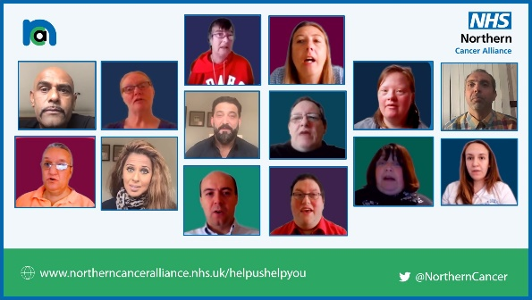
Be Cancer Aware’s ‘Time to Talk about Cancer’ film has been co-produced by learning disability groups across the #NorthEast and #Cumbria to help people understand more about #cancer @NorthernCancer  Watch it here: https://youtu.be/IaL-RcyQ9Vs | NCA BCA signs and symptoms  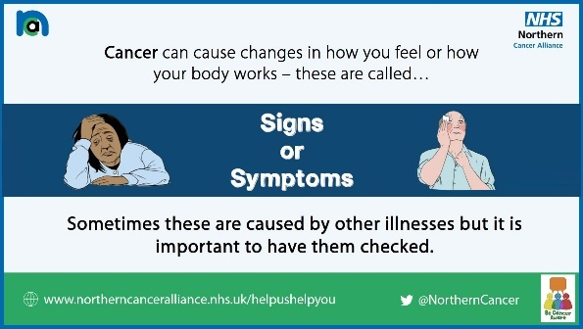
Find out more about the Be Cancer Aware co-production education project and the fantastic work they’re doing to raise awareness of #cancer for people with learning disability across the region ⬇️  https://youtu.be/9YR8E01CXas #HelpUsHelpYou @NorthernCancer | YouTube link will create thumbnail
Do you know the signs of cancer and what to do if you’re worried about possible symptoms?  This 👇 brilliant film has been created by the Be Cancer Aware group to help people with learning disabilities spot the signs of #cancer @NorthernCancer  https://www.northerncanceralliance.nhs.uk/helpushelpyou/resources-information/patient-information-our-communities/be-cancer-aware/ | NCA symptoms list  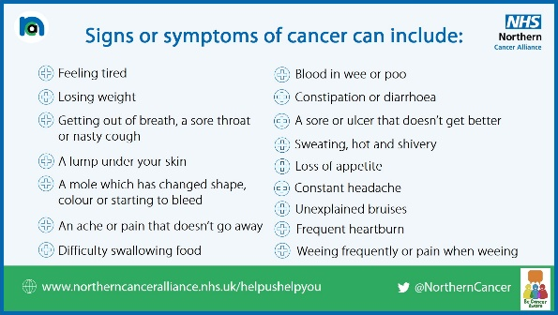
The NHS is still open for diagnosing and treating cancer. If you are worried about any signs or symptoms of cancer, don’t delay & talk to your doctor.  Find out more about @NorthernCancer’s #HelpUsHelpYou campaign & access a range of advice and information https://bit.ly/2VyBpG9 | NCA GP and hospitals  