Northern Cancer Alliance ‘Help Us Help You’
Week 4 communications toolkit
July, 2020

Please find below updated communications materials focusing on Week 4 of our Help Us Help You regional awareness campaign, which will focus on head and neck cancer.

Website/Intranet copy
Plea for people to be aware of the early signs of head and neck cancer

A northern cancer specialist is reminding people across the region to be aware of early signs of head and neck cancer and not to put off seeking help during the pandemic.

Amid the COVID-19 crisis, the number of people being referred urgently for suspected cancer has decreased in the region. As part of its Help Us Help You campaign, the Northern Cancer Alliance is working closely with partners throughout the North East and North Cumbria to encourage people to contact their GP or nurse if they are concerned about signs or symptoms of cancer.

The Alliance is supporting the Northern Head and Neck Cancer Charity’s ongoing awareness campaign which is urging people who are experiencing any unusual mouth or neck symptoms that have lasted for three weeks or more, not to delay visiting their doctor, dentist or pharmacist.

James O’Hara, Clinical Lead on the Northern Cancer Alliance’s Head and Neck Pathway Board, said: “The COVID-19 pandemic has proven particularly challenging and traumatic for many of us. But now that the environment is safer, we are particularly anxious that patients who have symptoms that may suggest they have cancer go to see their GP. Head and neck cancers cover a number of different cancer sites. The commonest are mouth cancers and voice box cancers. Head and neck cancer is usually treatable and usually curable, but only if we catch it early.”

Whether it’s non-healing mouth ulcers and/or red or white patches in the mouth, change in the tongue, pain in the throat, persistent hoarseness, painful or difficulty swallowing or lumps in the neck, these can be early warning signs of more serious mouth conditions that shouldn’t be ignored.

Nigel, who was diagnosed with cancer of the larynx seven years ago and had a laryngectomy, is supporting the Northern Cancer Alliance’s awareness campaign and has made a film asking people to reach out to their GP if they’re worried. In the film he says: “I was lucky that I was treated very quickly after diagnosis, which is one of the reasons why I can speak to you today. It’s vitally important if you feel you need to see a medical professional for any reason, especially if you feel concerned about cancer, that you should see them as soon as possible.”

Help Us Help You was launched to reassure people that cancer services remain a top priority for the NHS, and to encourage people not to delay contacting their GP or nurse if they are concerned about signs or symptoms of cancer.

A range of head and neck cancer information resources can be found on the Northern Cancer Alliance’s ‘Help Us Help You’ webpage at: https://www.northerncanceralliance.nhs.uk/helpushelpyou/resources-information/head-and-neck-help-us-help-you/

ENDS

Social media content
Please follow us on Twitter and tag us in your tweets @NorthernCancer
Post copy | Asset
If you have 1 of the below for 3 weeks, see your GP:  ◾ non-healing mouth ulcers &/or red or white patches in the mouth  ◾ change in the tongue  ◾ throat pain  ◾ persistent hoarseness  ◾ painful &/or difficulty swallowing  ◾ lumps in the neck  More info: https://www.northerncanceralliance.nhs.uk/helpushelpyou/resources-information/head-and-neck-help-us-help-you/ #HelpUsHelpYou | NCA head and neck treatable  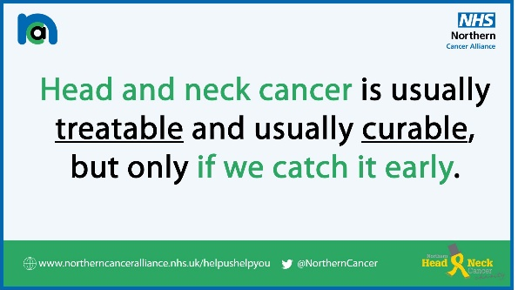
Diagnosing head and neck cancer early can save lives. Watch this @NorthernCancer film with #cancer specialist James O’Hara and take his advice – if you have any concerns, please see your doctor #HelpUsHelpYou  https://youtu.be/qhrG_WXfJRM | YouTube link will create thumbnail image
Head & neck cancer is usually treatable & curable when it’s caught early. Don’t delay seeking medical advice - it’s safe to visit your GP, dentist or pharmacist who will be able to help.  Find more information and resources via @NorthernCancer’s #HelpUsHelpYou webpage: https://www.northerncanceralliance.nhs.uk/helpushelpyou/resources-information/head-and-neck-help-us-help-you/ | NCA head and neck symptoms  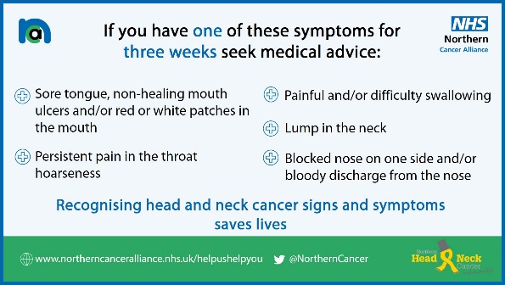
Nigel was diagnosed with cancer of the larynx. He was lucky that he was treated very quickly after diagnosis. He’s now urging people to contact their doctor as soon as possible if they feel concerned about their health @NorthernCancer #HelpUsHelpYou  https://youtu.be/gvNVmWTfOj8 | YouTube link will create thumbnail image

