Northern Cancer Alliance ‘Help Us Help You’
campaign communication toolkit
July, 2020

Help spread the word of the launch of the Northern Cancer Alliance’s ‘Help Us Help You’ regional campaign

The Northern Cancer Alliance has launched a regional drive to encourage people to talk to their GP or nurse if they are concerned about signs or symptoms of cancer. The campaign aims to raise awareness of cancer symptoms and the importance of early diagnosis, as well as offering reassurance that the NHS is working tirelessly to get people the best treatment for their cancer as quickly and as safely as possible. More information can be found here.

We would appreciate your support to amplify the campaign information within your networks to help us reach as many people as possible with these important messages. To make this as easy as possible, please find below some readymade content for distribution via your communications channels, this toolkit includes social media content and imagery, newsletter copy and a website/intranet copy.
The campaign launches on Wednesday 1st July, 2020, and will run for four weeks until 29th July. Each week there will be a different focus covering health inequalities, lung cancer and head and neck cancer. We will release additional communications resources on a weekly basis during the campaign which you will be able to download from the Communication Toolkit here: https://www.northerncanceralliance.nhs.uk/helpushelpyou/resources-information/

Social media content
Please follow us on Twitter and tag us in your tweets @NorthernCancer
Post copy | Asset
Spotting cancer early saves lives. We’re supporting @NorthernCancer’s awareness campaign which is urging people to speak to their GP if they are worried about any signs or symptoms of #cancer. #HelpUsHelpYou  Find out more: https://bit.ly/2VyBpG9 | NCA spot the signs or NCA signs and symptoms  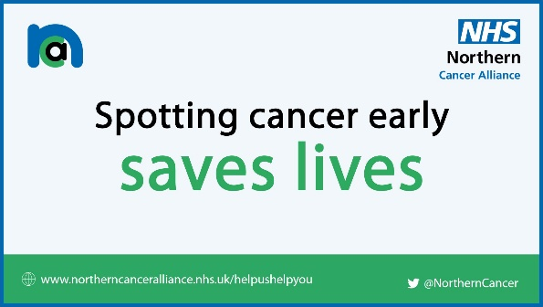  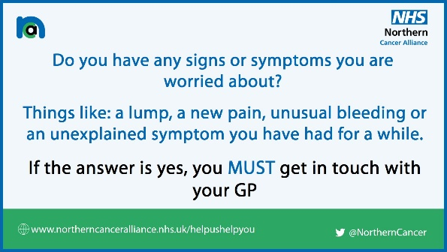
The NHS is still here for you when you need it during the pandemic. Please don’t delay seeking medical advice if you’ve noticed possible symptoms of #cancer, contact your GP or nurse today.  Read more about @NorthernCancer’s #HelpUsHelpYou campaign: https://bit.ly/2VyBpG9 | NCA GP and hospitals  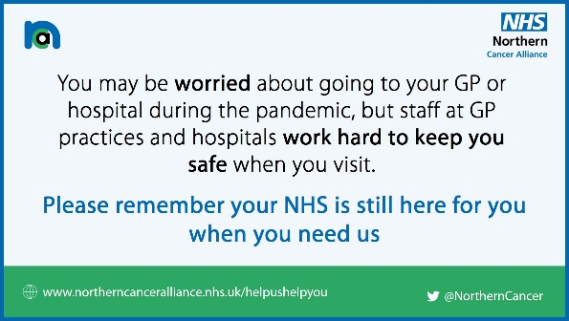
Have you noticed a lump, a new pain, unusual bleeding or an unexplained symptom?  Watch this film with #cancer care specialists explaining why it’s so important to get signs or symptoms of #cancer checked by a professional @NorthernCancer #HelpUsHelpYou  https://youtu.be/LnNT0CVkCa0 | YouTube link will create thumbnail image
Diagnosing cancer early saves lives. Watch this film with Maurice, a cancer survivor, encouraging anyone with #cancer symptoms to call their doctor as soon as possible @NorthernCancer #HelpUsHelpYou  🎞️ https://youtu.be/sGKyFkPzvvA | NCA Maurice film  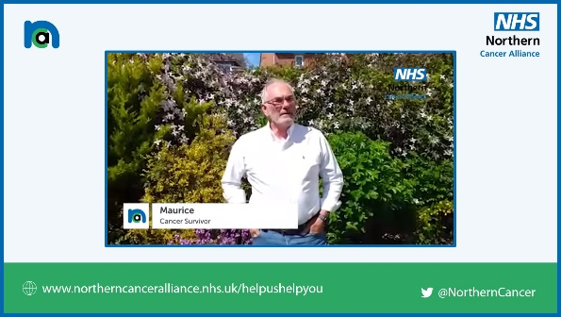
If you’re worried about accessing #NHS services during the #COVID19 pandemic, watch @NorthernCancer’s series of short films with people who have lived experience of #cancer treatment and attending hospital appointments during the pandemic #HelpUsHelpYou  🎞️ https://www.northerncanceralliance.nhs.uk/helpushelpyou/patient-information/ | NCA NHS here for you  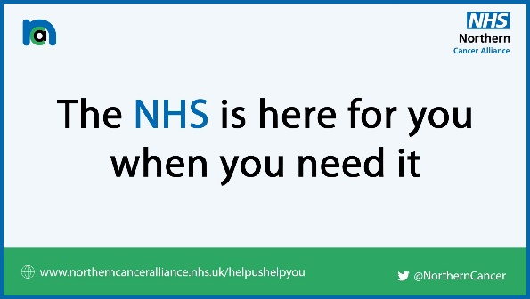

Newsletter copy (short)
Worried about a possible sign or symptom of cancer? Don’t delay, contact your GP today

Regional cancer care specialists are urging the public not to delay seeking medical advice if they are worried about possible symptoms of cancer.

Following a drop in the number of people being referred urgently for suspected cancer during the COVID-19 pandemic, the Northern Cancer Alliance has launched a regional awareness campaign to encourage people to contact their GP or nurse if they are concerned about signs or symptoms of cancer. Whether it’s a lump, a new pain, unusual bleeding or an unexplained symptom, recognising the signs and getting them checked out as soon as possible could help save lives.

It’s also important for people to attend any referral or follow up appointments, which are being delivered safely by frontline teams during the pandemic.

To find out more about the regional ‘Help Us Help You’ activity, which supports a wider national campaign, and to watch a series of films with patients and cancer care specialists from across the region, visit: https://www.northerncanceralliance.nhs.uk/helpushelpyou

Website/Intranet copy (long)
Regional cancer care specialists are urging the public not to delay seeking medical advice if they are worried about possible symptoms of cancer

Health leaders from across the North East and North Cumbria have launched a drive to encourage anyone with potential signs of cancer to make use of NHS services.

There has been a drop in the number of people being referred urgently for suspected cancer during the COVID-19 pandemic - with a 76% reduction at the peak of the crisis in mid-April. Numbers are increasing each week, however the latest data still shows a decrease of around a third.

Essential and urgent cancer diagnosis, treatment and care is continuing throughout the pandemic and the NHS is working to get people the best treatment for their cancer as quickly and safely as possible.

The Northern Cancer Alliance has launched the regional ‘Help Us Help You’ campaign to urge people to talk to their GP or nurse if they are concerned about signs or symptoms of cancer. Whether it’s a lump, a new pain, unusual bleeding or an unexplained symptom, recognising the signs and getting them checked out as soon as possible could help save lives.

It’s also important for people to attend any referral or follow up appointments, which are being delivered safely by frontline teams during the pandemic.

The area covered by the Northern Cancer Alliance has the second highest rate for incidence of all cancers when compared to other Cancer Alliances in England and has the highest rate incidence rate for females. It also has the highest mortality rate from all cancers for males, females and persons.

Angela Wood, Northern Cancer Alliance Secondary Care Clinical Director, said: “During the pandemic, fewer people are talking to their doctors about symptoms of cancer. We understand people have followed guidance to stay at home, but we are worried that people with symptoms or signs that could be cancer, are not getting the care they need.

“We urge anyone with any symptoms or signs that they are worried about, such as unusual bleeding, a lump, a new unusual pain or a prolonged unexplained symptom to contact their GP or nurse. GP surgeries offer online and telephone consultations so we can talk to people first, agree any further actions to be taken and stop people attending the surgery unnecessarily.

“Some patients are choosing to delay important hospitals appointments due to their reluctance to visit a hospital during the pandemic. We can reassure patients that all of our cancer teams protect the safety of their patients by strictly following government guidelines and our hospitals have changed the way they work to keep you safe.”

The delivery of cancer services remains a top priority for the NHS. During the ongoing pandemic, cancer teams across the region have been working closely to make safe areas to assess and treat people for cancer.

Katie Elliot, Northern Cancer Alliance Primary Care Clinical Director, added: “It is very important that anyone with symptoms and signs that might be cancer makes contact with their GP. However, we understand there are concerns about delays to cancer treatments during the COVID-19 pandemic.

“Throughout the pandemic, emergency and urgent treatment for cancer has continued, despite the impact of the pandemic, on availability of operating theatres and staff and the need to protect staff and the public.

“Any delayed treatment have been reinstated based on the clinical need and individual patient risks. Regional clinical teams are working together to share surgical and therapy capacity, making sure that clinical needs are met.

“For some people, in line with guidance, some treatments have been adjusted to continue to treat the patient’s condition, whilst minimising the risk from COVID-19. The regional NHS teams continue to deliver cancer treatments, as safely as possible, throughout the pandemic.”

The Northern Cancer Alliance’s region-wide public information campaign will have a different focus each week covering health inequalities, lung cancer, and head and neck cancer. The messages will be shared far and wide using newspaper print and digital adverts, radio adverts, social media, posters and leaflets in GP surgeries, hospitals and in community settings and food banks.

The campaign has been developed working in partnership with members of the community including people with lived experience of cancer treatment and attending urgent cancer referral appointments during the pandemic. You can watch a series of films developed with patients here.

The campaign has also been supported by Cancer Research UK, North East and Cumbria Learning Disability Network, North East and North Cumbria Integrated Care System and North of England Commissioning Support Unit.

Watch the Northern Cancer Alliance’s campaign film for further information, here: https://youtu.be/LnNT0CVkCa0

Find out more about the ‘Help Us Help You’ regional campaign at: https://www.northerncanceralliance.nhs.uk/helpushelpyou

ENDS

(2017 incidence data from NCRAS)

