Northern Cancer Alliance
Breast cancer case study social media plan

Post copy | Asset
The NHS is still here for you when you need it during the pandemic. Don’t delay seeking medical advice if you’ve noticed possible symptoms of #cancer – read this story from a #breastcancer patient’s experience of diagnosis & treatment https://teesvalleyccg.nhs.uk/cancer-during-covid-19-clares-story/ #BreastCancerAwarenessMonth | Breast cancer quotes 1  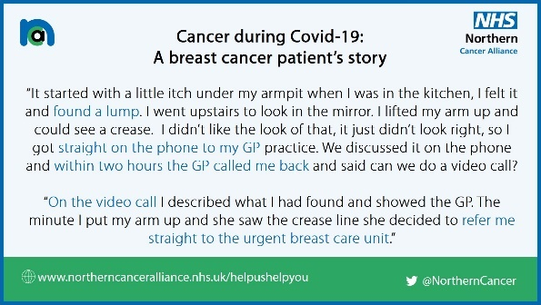
After feeling an itch in her armpit and then finding a lump, a North East mum has shared her story of diagnosis, surgery and chemotherapy during lockdown #BreastCancerAwarenessMonth  https://teesvalleyccg.nhs.uk/cancer-during-covid-19-clares-story/ | Breast cancer quotes 2  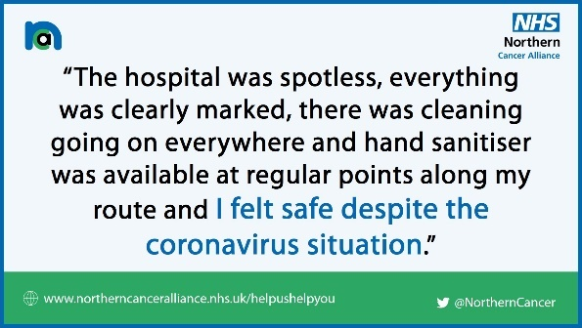
Have you noticed a lump, a new pain, unusual bleeding or an unexplained symptom?  This 👇 story from a #breastcancer patient highlights why it’s so important to get signs or symptoms of #cancer checked by a professional as soon as possible #BreastCancerAwarenessMonth  https://teesvalleyccg.nhs.uk/cancer-during-covid-19-clares-story/ | Breast cancer quotes 3  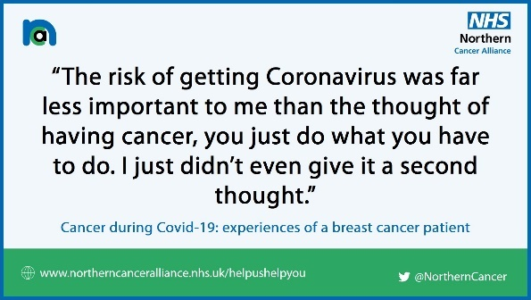
Diagnosing cancer early saves lives. During the pandemic the NHS is still here to investigate, diagnose & treat cancer – as it did for the below North East mum. Read her #breastcancer story ⬇️  https://teesvalleyccg.nhs.uk/cancer-during-covid-19-clares-story/ #BreastCancerAwarenessMonth | Breast cancer quotes 4  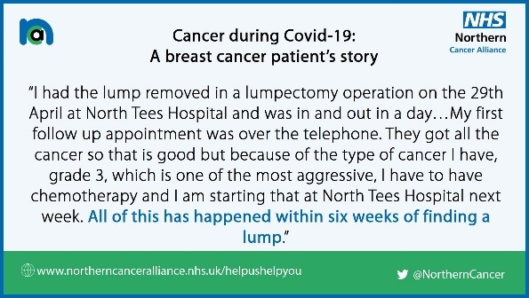
The NHS is open for diagnosing and treating cancer. Please follow the advice of this 👇 patient, who was diagnosed and treated for breast cancer during lockdown. Don’t let fear stop you from accessing #NHS services during the #COVID19 pandemic #BreastCancerAwarenessMonth https://teesvalleyccg.nhs.uk/cancer-during-covid-19-clares-story/ | Breast cancer quotes 5  