Your referral to the rapid diagnosis service

 | - The rapid diagnostic service is a team of people who will help you find out why you are unwell
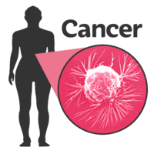 | - They will try to find the cause of your symptoms and see if you have or have not got cancer
- A member of our team will be in touch with you within two working days
The hospital number may show as unknown or a private number on your phone
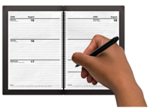 | - Your appointment is important – if you cannot make it please let the team know
- At your first appointment: -
- You will need to bring a list of your current medications
- You will be asked lots of questions
- You may have some tests to help find the cause of your symptoms – these will be explained to you
- You will have an examination of your body so please wear comfortable clothing
- You are welcome to bring someone with you to your appointment
- After your appointment: -
- You may be brought back in to clinic
- More tests may be needed – these will be explained to you
- Your test results will be explained to you
- Based on your results a plan will be made with you about what will happen next
- Your results will be shared with your GP – these can be shared with another named person if you want, such as a family member or carer
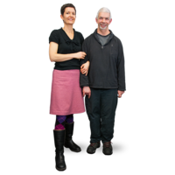 | - Throughout your time with us a cancer care coordinator will support you
- If you have any questions or worries please contact the team on:
Add telephone number
Add email address

