Practice headed paper – This letter includes text boxes to be completed before sending

Dear Click here to enter text.
We are inviting you for cervical screening.
This is sometimes called a smear test.
Easy read leaflets can be found at:

https://www.gov.uk/government/publications/cervical-screening-easy-read-guide

Or

http://www.jostrust.org.uk/resources/materials/information

A YouTube video is available at:

https://www.jostrust.org.uk/video-page/smear-test-film
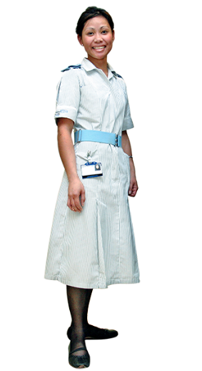 | The nurse at the surgery can tell you more about cervical screening.
 | To make an appointment phone Click here to enter text. or come into the surgery.
 | You can bring a friend or carer with you.
Confused or worried.
If you need more help to understand cervical screening the learning disability team can help.
The community learning disability team can be contacted on

East Cumbria 01228 603189
South Cumbria 01229 401100
West Cumbria 01900 705825

Yours sincerely

